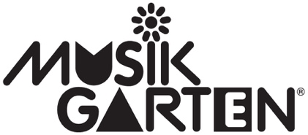
Gate City Musikgarten
Oath of Personal Responsibility, for all teachers and class participants

At Gate City Musikgarten, and the various institutions at which our classes are held, our priority is the safety of our children, their families, and the larger community. Working together as a team, we can take measures within our control to best ensure the health and safety of all.

I, (please print name) ________________________________________, am aware of the potential spread of COVID-19 that could result in severe illness and potential death.
Therefore, I (and my children enrolled in classes with Gate City Musikgarten as well as family members) will, to the best of our ability, take all necessary precautions as recommended by health department directives, as well as practice good hygiene (handwashing, use of sanitizer, disinfecting shared items, etc.) and follow other health recommendations set forth by Gate City Musikgarten or their class sites (masking, etc.).
Should I or my child show signs of illness, we will stay home from classes. We will adhere to testing guidelines and work with our own primary care providers.
If I (or enrolled children or family members) test positive for, or are exposed to COVID-19, we will notify my child’s teacher (or Melissa Zacharias, gcmusikgarten@gmail.com) and refrain from attending class until the quarantine period has passed.
I release Gate City Musikgarten and the institutions at which classes are held (____________________________________) from any and all liabilities regarding unintentional exposure to COVID-19.

Signature ______________________________________ date ________________________

Name(s) of enrolled children ___________________________________________________
___________________________________________________
___________________________________________________

